西南交通大学模拟考试试卷
班 级 学 号 姓 名
密封装订线 密封装订线 密封装订线
课程代码 0173234 课程名称 General Physics I考试时间 120分钟
题号 | 一 | 二 | 三 | 四 | 五 | 六 | 七 | 八 | 九 | 十 | 总成绩
得分

阅卷教师签字：
INSTRUCTIONS: Please read ALL of these before doing anything else!!!
Make your work clear to the grader. Show the formulas you use, all the essential steps, and results with correct SI units and correct signiﬁcant ﬁgures. Partial credit is available if your work is clear. Unless otherwise requested, give results in SI units (with preﬁxes if convenient).
Conversions:
1 inch = 2.54 cm, 1 ft = 12 in = 0.3048 m, 1 mile = 5280 ft, 1 lb. = 4.45 N, Speed of sound in air (20◦C): 343 m/s, 1 hp = 746 W, G = 6.67 ×10−11 N m2/kg2, g = 9.80 m/s2, R = 8.314 J/mol·K, NA = 6.022×1023/mol, 1 u = 1.6605×10−27 kg, kB = 1.38×10−23 J/K, 1 cal = 4.186 J, 1 atm = 101.3 kPa.

- Choice question(3 points each, 45 points total)
- If you are riding a bicycle to the west with speed . meanwhile the wind with the same speed is blowing from the direction of 30 ° north by east, so which direction did you find the wind blew from? [ ]
(A) 30 ° north by east (B) 30 ° south by east
(C) 30 ° north by west (D) 30 ° south by west
- If a car is moving along a winding road at constant speed, which of these quantities is zero? [ ]
(A) its displacement. (B) its velocity.
(C) acceleration. (D) its change in kinetic energy.
- A particle moves in a general curvilinear motion, its instantaneous velocity is , the instantaneous speed is V, the average velocity in a certain period of time is , the average speed is, and the relationship between them is: [ ]
（A）∣∣=V，∣∣= ； （B）∣∣≠V，∣∣= ；
（C）∣∣≠V，∣∣≠ ； （D）∣∣=V，∣∣≠
- A particle moves in a plane, and the expression of the position vector of the particle is given 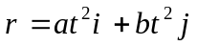,(where a and b are constants), then the particle is moving in: [ ]
(A) uniform linear motion (B) linear motion with variable speed.
(C) parabolic motion. (D) general curvilinear motion.
- A moving particle is located at the endpoint of the displacement vector 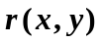 at time t, and its velocity is: [ ]
(A) 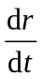； (B) 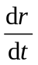； (C) 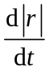； (D) 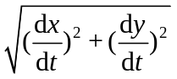
- A ball is thrown vertically upwards. What is the direction of its acceleration at the highest point it reaches? [ ]
(A) Downwards, (B) Upwards, (C) At that point, the acceleration is zero, (D) At that point, the acceleration is zero and point Downwards.
- You throw a baseball straight up in the air and it comes back to the launch point in 2.5 seconds. Which quantity would have to be doubled to make it stay in the air for twice as long? [ ]
(A) the ball’s initial speed. (B) the ball’s initial kinetic energy.
(C) the ball’s initial potential energy. (D) the ball’s mass
- Two small balls of equal mass are connected by a light spring and suspended from the ceiling by a string in a static state, as shown in the figure. The moment the string is cut off, the acceleration of ball 1 and ball 2 is [ ] respectively.
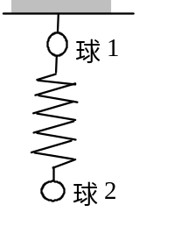
(A) 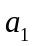＝ｇ，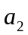＝ｇ． (B) ＝0，＝ｇ．
(C) ＝ｇ，＝0． (D) ＝2ｇ，＝0．
- A rigid body is composed of a homogenous thin rod and a homogenous sphere. The rod is on the extension line of the diameter of the sphere, as shown in the figure. The radius of the sphere is , the length of the rod is 2, and the mass of both the rod and the sphere is m. For the axis perpendicular to the rod and passing through the center of the rod 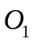 the moment of inertia of the rod is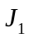, and the moment of inertia of the sphere pair passing through the center of the sphere is 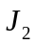, then the moment of inertia of the whole rigid body (rod and sphere) for the axis perpendicular to the rod and passing through the point  of consolidation between the rod and the sphere is [ ]
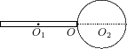
(A) 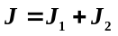； (B) 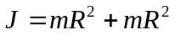；
(C) 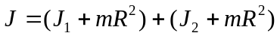；
(D) 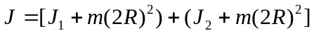。
- The density of the two homogeneous disks A and B are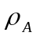and 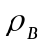respectively. >, but the mass and thickness of the two disks are the same, if the moment of inertia of the two disks are respectively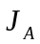 and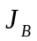, for the axis passing through the center of the disk and perpendicular to the surface of the disk . Then [ ]
（A）> （B）>
（C）＝ （D）I couldn’t find which is larger
- The dynamic equation of a particle with mass m under external force is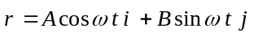,A and B are all positive constants. What is the work done by external force in the time interval t=0 to
t=π／(2ω) [ ]
(A) 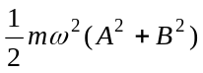。 (B) 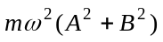。
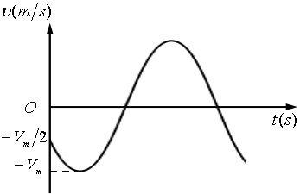
(C) 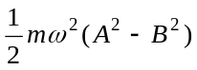。 (D) 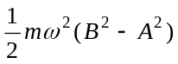
- There is a simple harmonic vibration expressed by cosine function. If the relation curve between its velocity and time is shown in the figure, the initial phase of the vibration is [ ]
(A) 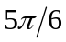； (B) 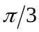；（C） 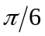 （D） 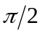
- A spring oscillator performs simple harmonic vibration. When its displacement from the equilibrium position is 1/4 of its amplitude, its kinetic energy is the total vibration energy [ D ]
（A）7/16； （B） 9/16； （C） 11/16；（D） 15/16
- The wave function of a plane simple harmonic wave is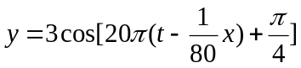 (SI) and the vibration curve of the particle at the point 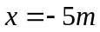 is shown in figure [ ].
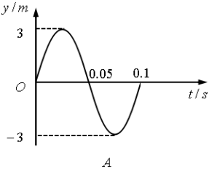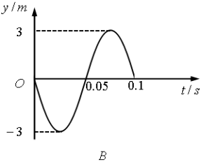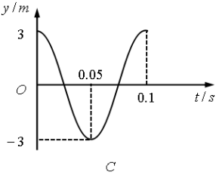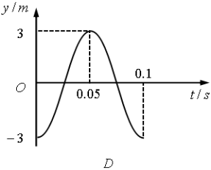
- The first law of thermodynamics is a restatement of which of the following? [ ]
(A) Newton's first law
(B) the law of conservation of energy
(C) momentum conservation law
(D) Newton's second law


- Gap filling(2 points each, 30 points total)
- As shown in the figure, the mass of the pendulum ball of the conical pendulum is m, its speed is v, and the radius is R. When the pendulum ball moves in half a circle on the orbit, the magnitude of the gravitational impulse on the pendulum ball is , and the work done by gravity is
- If the mass of a particle is m and the velocity is v, then the kinetic energy of the particle is ;The total mass of a rigid body is M, the moment of inertia is J , the velocity of center of mass is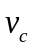, and the rotational angular velocity is, then the total kinetic energy of the rigid body is
- One end of the string connects a ball of mass m, and the other end passes through the smooth hole in the horizontal table. The ball rotates at angular velocity 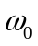, and a force F pulls the string so that the rotation radius decreases from r₀ to r₀/2. The work done by the force is , the final angular velocity is .
- According to maxwell's law of speed distribution, the most probable speed of gas molecules 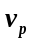= , Average speed = , square mean root speed 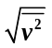=
- A certain amount of ideal gas will undergo the following three processes :(1) isobaric process;(2) isothermal process;(3) adiabatic process. Where, the process gas does the most work. process gas energy increases the most; The process gas absorbs the most heat.
- Wave coherence conditions are:

- Calculation
- (10points) As shown in the figure, a light rope spans two fixed pulleys with mass m and radius R, and the blocks attached to both ends of the rope with mass M and 2M respectively. The system is released from stillness. Please formulate the relationship of the acceleration and tension of the rope between the two pulleys without calculation. Notice :the rope length is constant and its mass is not counted, the rope and pulley do not slip, and the pulley's mass is even. The moment of inertia of the pulley can be calculated as a disk, and the friction at the axis is not counted.
M
m
2M
m
R
R
Solution：
The analysis based on the free diagram shows that :

- (10points) Suppose the expression of the incident wave is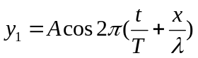, the reflection occurs at , and the reflection point is a fixed end, please find :(1) the expression of the reflected wave;(2) expression of the superposition wave;

- （5points）A certain amount of ideal gas changes its state from equilibrium a to equilibrium b along a straight line on the V-T diagram (see figure). Please prove this is an endothermic depressurization process(吸热降压过程)

